Doug Dvorak  Doug Dvorak is the CEO of DMG International, a worldwide organization that assists clients with productivity training and motivational excellence management workshops. Mr. Dvorak's clients are characterized as Fortune 1000 companies, small to medium businesses and service businesses. Mr. Dvorak has earned an international reputation for his powerful educational methods and motivational techniques, as well as his experience in all levels of sales & sales management, corporate education and success training. His background in sales, leadership, and management has allowed him to become one of world’s most sought-after sales consultants, lecturers and teachers. This vast experience has helped him shape and determine his philosophies on motivation & sales success. | 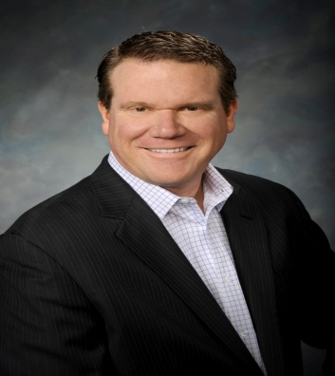
Mr. Dvorak is a certified management consultant, sales trainer, and executive coach and holds a Bachelor of Arts degree in Business Administration and a Master of Business Administration in Marketing Management. But Mr. Dvorak's sense of humor is no less refined, as he is a graduate of the Player's Workshop of the Second City, one of the oldest and most prestigious improvisational comedy schools in the world.
Mr. Dvorak's philosophies have been featured in several articles and interviews including; The Wall Street Journal. CNN, CBS and other national & international publications. His dedication to success and sales excellence led him to be named one of the Top Ten Sales Professionals in America by Personal Selling Power Magazine.
Mr. Dvorak is a member of the National Speakers & was inducted into the Motivational Speaker’s Hall of Fame in August 2014. Doug is also a Certified Speaking Professional (CSP) the highest earned designation from the National Speakers Association (NSA). Doug has presented to over 1 Million people on 5 continents.

